4.1 Related Rates Worksheet

- A cylindrical tank with radius 10ft is being filled with water. The water is being poured into the tank at a rate of 5 gal/min. How fast is the height of the water in the tank changing when the height is 7 ft. (Express your answer in ft/min. Note that 1 )
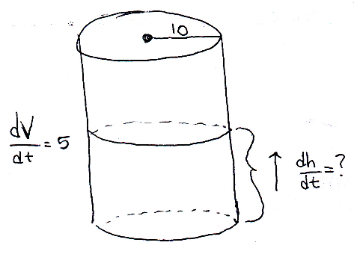
Step 1:
Step 2:
Step 3:
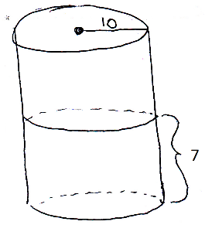
The height of the water is increasing at a rate of roughly .

- Air is being pumped into a spherical balloon so that its volume increases at a rate of 100 cm³/s. How fast is the radius of the balloon increasing when the diameter is 50 cm?
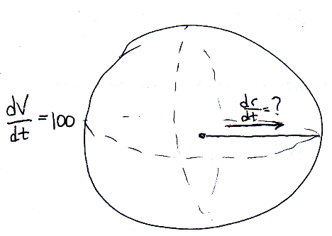
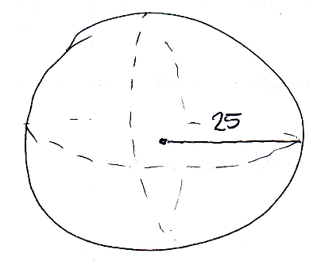
Step 1:

Step 2:

Step 3:
The radius of the balloon is increasing at a rate of .
- A man walks along a straight path at a speed of 4 ft/s. A searchlight is located on the ground 20 ft from the path and is kept focused on the man. At what rate is the searchlight rotating when the man is 15 ft$.$ from the point on the path closest to the searchlight?

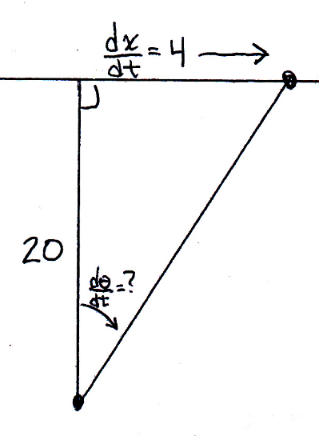
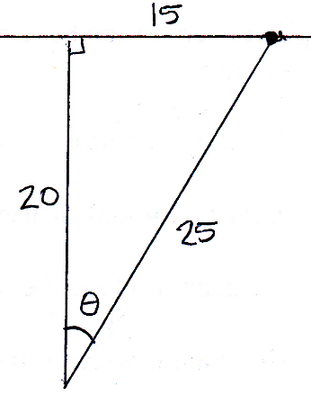
Step 1:

Step 2:

Step 3:
The rate at which the searchlight is rotating is .

- An observer stands 200 meters from the launch site of a hot-air balloon. The balloon rises vertically at a constant rate of 4 meters per second. How fast is the angle of elevation of the balloon increasing 30 seconds after the launch?
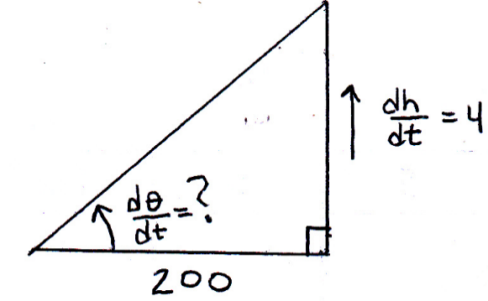
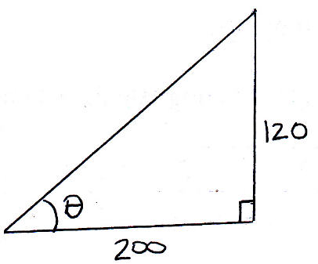
Step 1:

Step 2:

Step 3:

The rate of change of the angle of elevation is .

- A ladder 25 feet long is leaning against the wall of a tall building. The base of the ladder is sliding away from the wall at a rate of 2 feet per second. Consider the triangle formed by the side of the building, the ladder, and the ground.
- Find an equation for rate of change of the height of the ladder.

We need to find a value for .
By the Pythagorean Theorem we know that:
Then we calculate:

- Find the rate at which the area of the triangle is changing when the base of the ladder is 7 feet from the wall. (you will need to use the information from part (a) at some point)

Step 1:
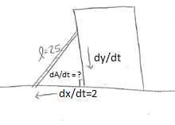

Step 2:

Using the information from part (a) we can rewrite this as:
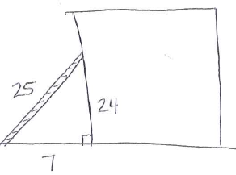

Step 3:

The rate of change of the area of the triangle is .

- A particle moves along the curve . As the particle passes through the point , its x-coordinate increases at a rate of 15 cm/s. How fast is the distance from the particle to the origin changing at this instant?
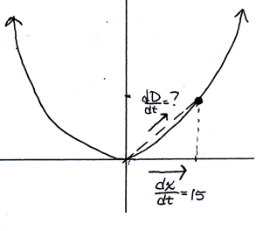
Step 1:

Step 2:

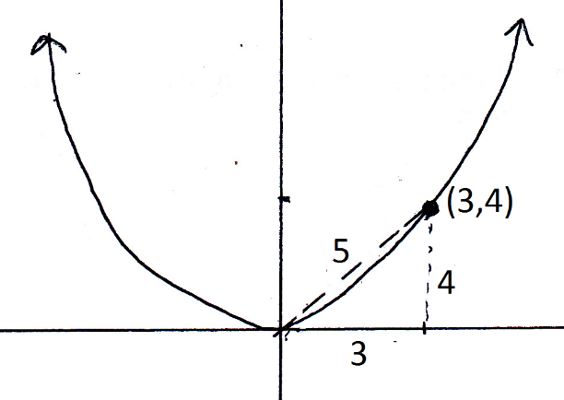

Step 3:
At we can see that
Therefore,

The rate of change of the distance between the origin and the particle is 41 cm/sec.

- A ladder 10ft long rests against a vertical wall. If the bottom of the ladder slides away from the wall at a rate of 1 ft/sec, how fast is the top of ladder sliding down the wall when the bottom of the ladder is 6ft from the wall?
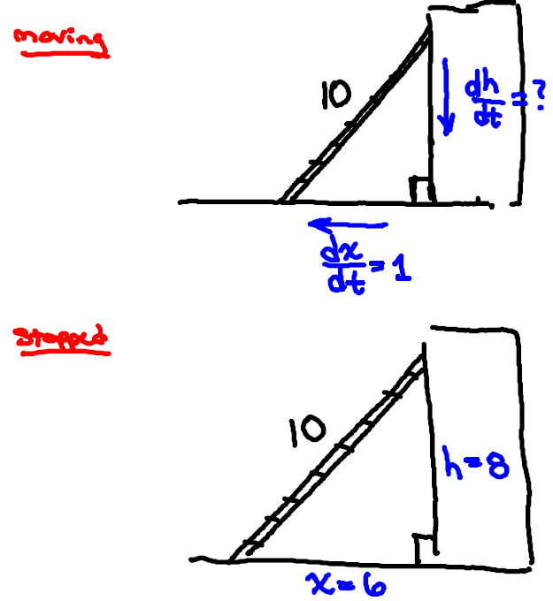
Step 1:

Step 2:

Step 3:

The top of the ladder is sliding down the wall at a rate of .

- A particle is moving along the curve . The x-coordinate of the point is moving at a rate of 1.5 cm/sec. What is the rate of change of the distance between the particle and the origin at the when the particle has an $x$-coordinate of 1.

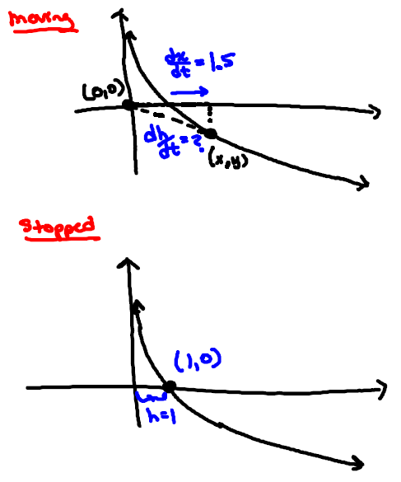
I will refer the distance using the letter h.

Step 1:

Step 2:

Step 3:

The rate of change of the distance between the origin and the particle is 1.5 cm/sec.

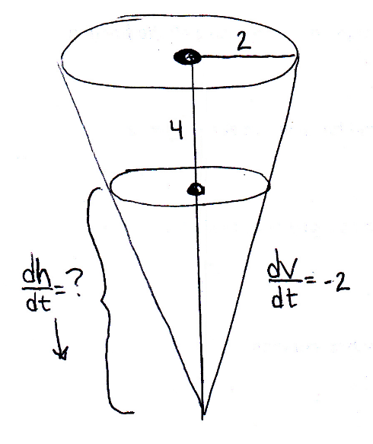
- A water tank has the shape of an inverted circular cone with a base radius 2m and height 4m. If water is being pumped into the tank at a rate of , find the rate at which the water level is rising when the water is 3m deep.

Step 1:

By similar triangles we obtain:

So we express the volume of water in the tank as:
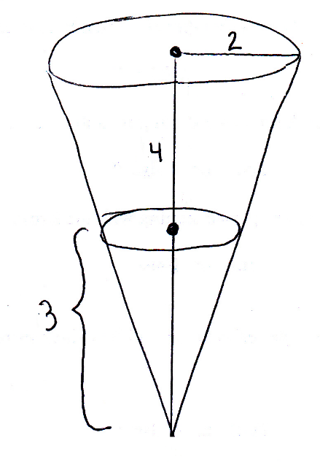

Step 2:

Step 3:

The height of the water is rising at rate of .

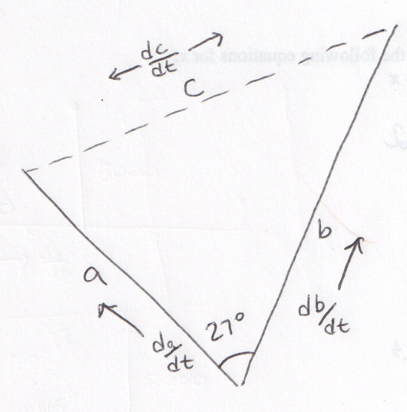
- Two cruise ships depart from the same port along courses which differ by an angle of . The first ship moves at a rate of 15 knots/hr while the second ship travels at 21 knots/hr. What is the rate of the change of the distance between the two ships after one day?
(Hint: It may be helpful to use the Law of Cosines!)

Step 1:

Step 2:

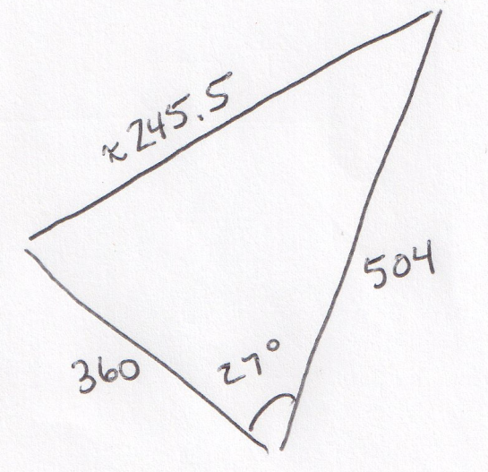

Step 3:

The rate of change of the distance between the ships is .

